COMPUTER VISION
PROJECT REPORT

ATTENDANCE SYSTEM USING FACIAL RECOGNITION

Puranjay Kapoor-23BHI10003

INDEX
PAGE NO. | CHAPTER
1 | FRONT PAGE
2 | INDEX
3 | ABSTRACT
4 | INTRODUCTION
5 | BACKGROUND INFORMATION
6 | DETAILS ABOUT PYTHON CONCEPTS USED
7 | METHODOLOGY
8 | IMPLEMENTATION
9 | RESULTS
10 | CONCLUSION
11 | REFERENCES

ABSTRACT
This project introduces an attendance management system developed in Python, featuring facial recognition technology. Traditional attendance methods are often time-consuming and prone to inaccuracies, making automation crucial. This system captures images through a webcam using OpenCV, recognizes faces using Deepface, and manages attendance records with Pandas. The user-friendly interface is built with Streamlit, while Streamlit Authenticator ensures secure login.

Facial recognition technology has emerged as a reliable alternative to traditional attendance systems. This project combines various Python libraries to create an efficient, accurate, and secure system. By automating attendance tracking, it reduces the scope for errors and fraudulent practices. This innovative approach not only simplifies the process for users but also enhances administrative efficiency. The project's success in improving attendance management underlines the potential of facial recognition technology in various educational and professional settings.

INTRODUCTION
Attendance tracking is a fundamental aspect of managing educational institutions, corporate offices, and diverse organizations. Traditional methods, like manual sign-in sheets and RFID cards, are cumbersome and prone to errors. In response to these challenges, this project leverages facial recognition technology within the Python ecosystem to provide an efficient and secure solution.
Our system automates the attendance process, offering swift and precise tracking of attendees. It combines OpenCV for image capture, Deepface for facial recognition using models like Facenet and VGG-Face, and Pandas for data management. The user-friendly front-end is created with Streamlit, and security is ensured through Streamlit Authenticator.
By fusing computer vision, machine learning, and web development, this project modernizes attendance tracking in diverse settings. It replaces manual processes with a reliable, efficient, and secure solution, allowing organizations to focus on more critical tasks while simplifying attendance management.

BACKGROUND INFORMATION
Traditional attendance systems, relying on manual processes like paper registers or electronic methods such as RFID cards, have proven to be inefficient, error-prone, and sometimes insecure. In contrast, facial recognition technology, powered by computer vision and deep learning, offers a highly accurate and reliable solution.
Facial recognition works by capturing and comparing unique facial features. In this project, Deepface, utilizing pre-trained models like Facenet and VGG-Face, performs this task effectively. Python's extensive libraries, including OpenCV for image processing and Pandas for data management, make it a suitable platform for implementing facial recognition-based attendance systems.
Streamlit, a user-friendly web application framework, simplifies the creation of a front-end interface, enhancing accessibility for a wide range of users. This project capitalizes on the strengths of facial recognition technology and Python to overcome the limitations of traditional attendance methods, offering an efficient, accurate, and secure solution for attendance management in various educational and professional settings.

PYTHON CONCEPTS
The development of the facial recognition-based attendance system involved the application of several fundamental Python concepts:
- Image Processing: OpenCV, an integral library for image processing, was employed for capturing images from the webcam, conducting facial detection, and performing various image manipulations.
- Deep Learning: Deep learning principles played a pivotal role in this project, primarily through the utilization of the Facenet and VGGFace models. These models are at the forefront of deep learning and deliver high accuracy in facial recognition. Proficiency in deep learning concepts and the ability to implement and train models, often using frameworks like TensorFlow or PyTorch, are vital for the success of the facial recognition system.
- Data Handling: Pandas, a popular data manipulation library, was used to manage attendance records, stored in CSV files. Pandas simplifies data storage, retrieval, and manipulation, ensuring that attendance data is efficiently organized and readily accessible for reporting and analysis. An understanding of data manipulation in Python is indispensable for effective data management in the project.
- Web Application Development: The user interface of the attendance system was constructed using Streamlit, a Python web application framework. Streamlit simplifies web application development and data visualization, enabling developers to create interactive and userfriendly interfaces with ease. Proficiency in web application development using Python, particularly with Streamlit, is vital for crafting a seamless user experience.
- User Authentication: Secure user access is facilitated by Streamlit Authenticator, an extension of Streamlit. This concept encompasses user management, access control, and ensuring the privacy and security of attendance records. Knowledge of user authentication and the integrity and confidentiality of the attendance system.

METHODOLOGY
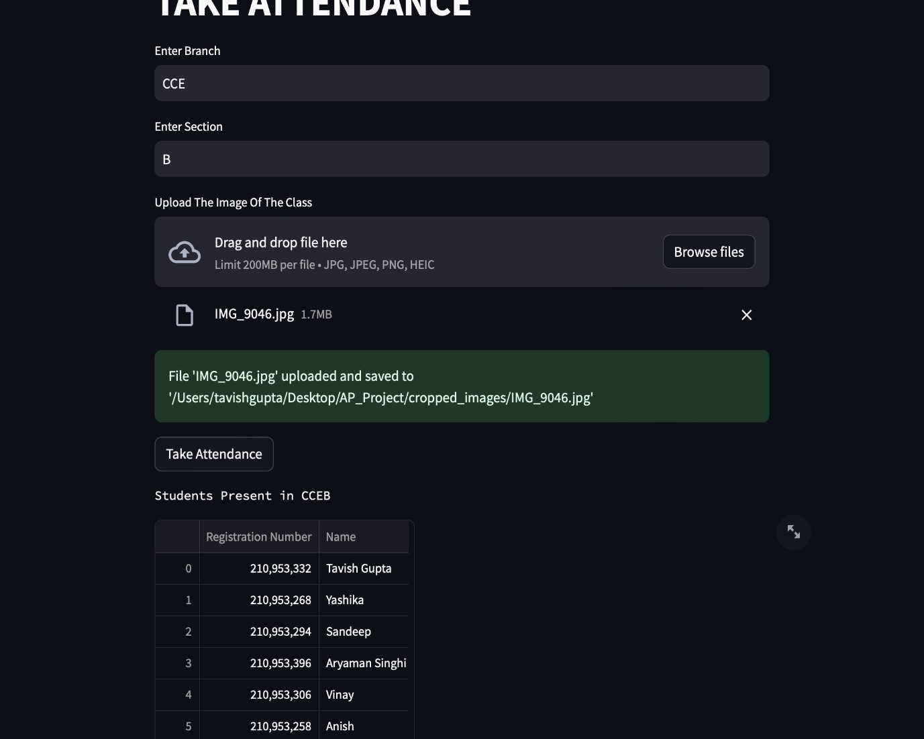
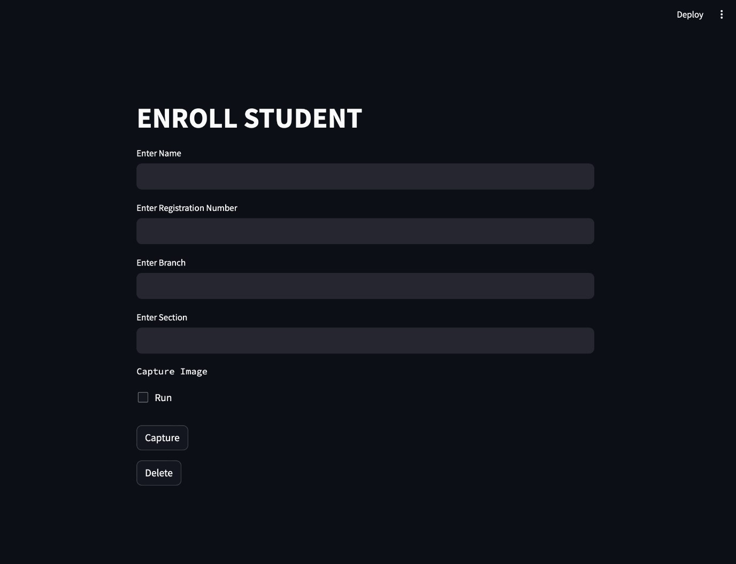

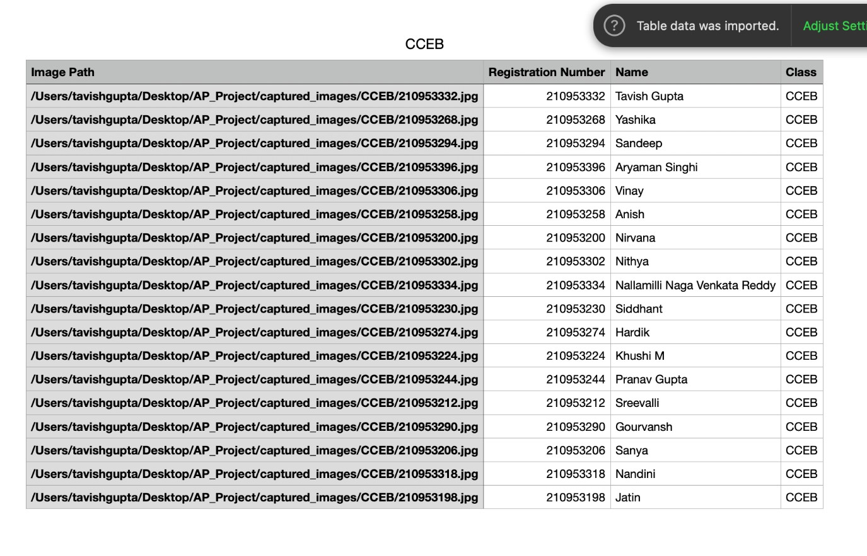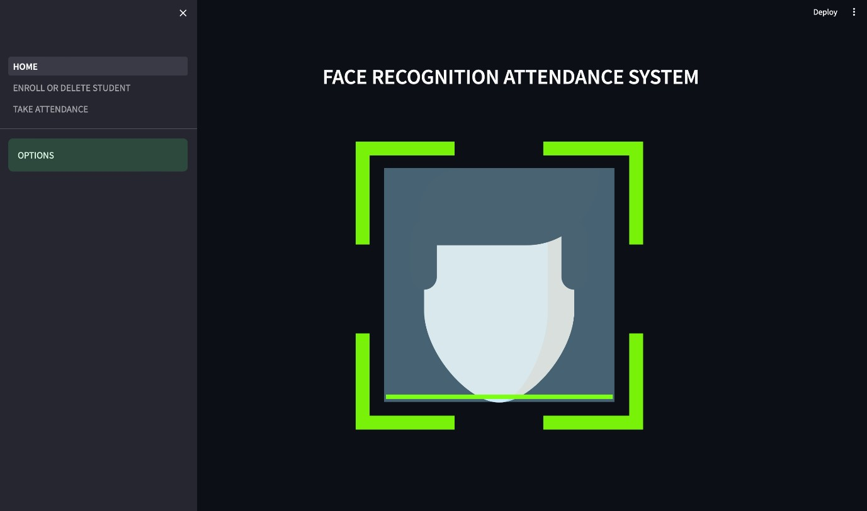

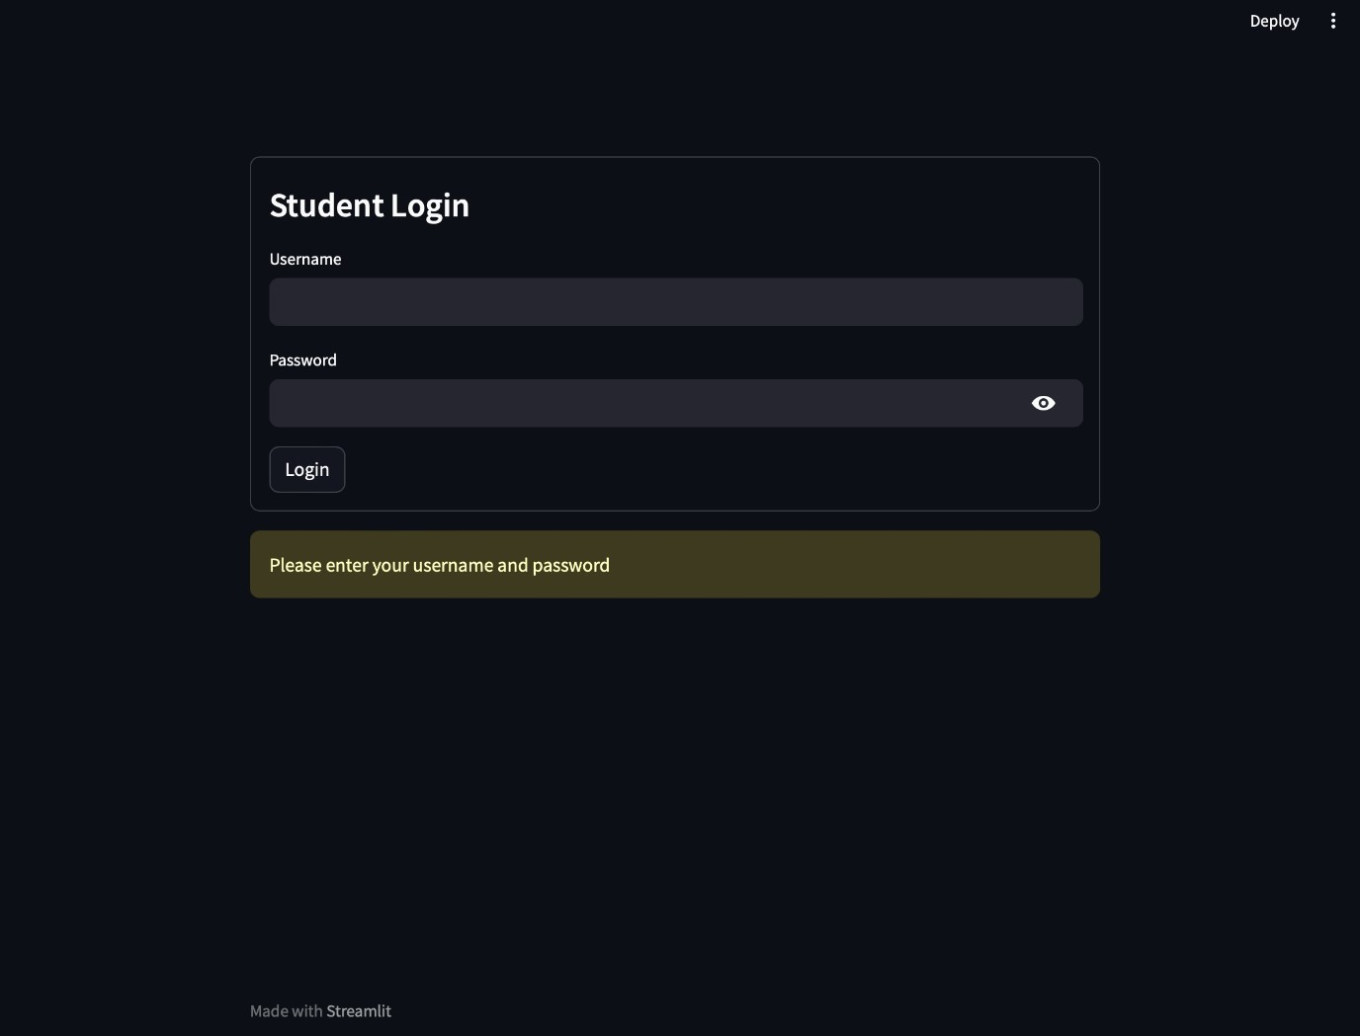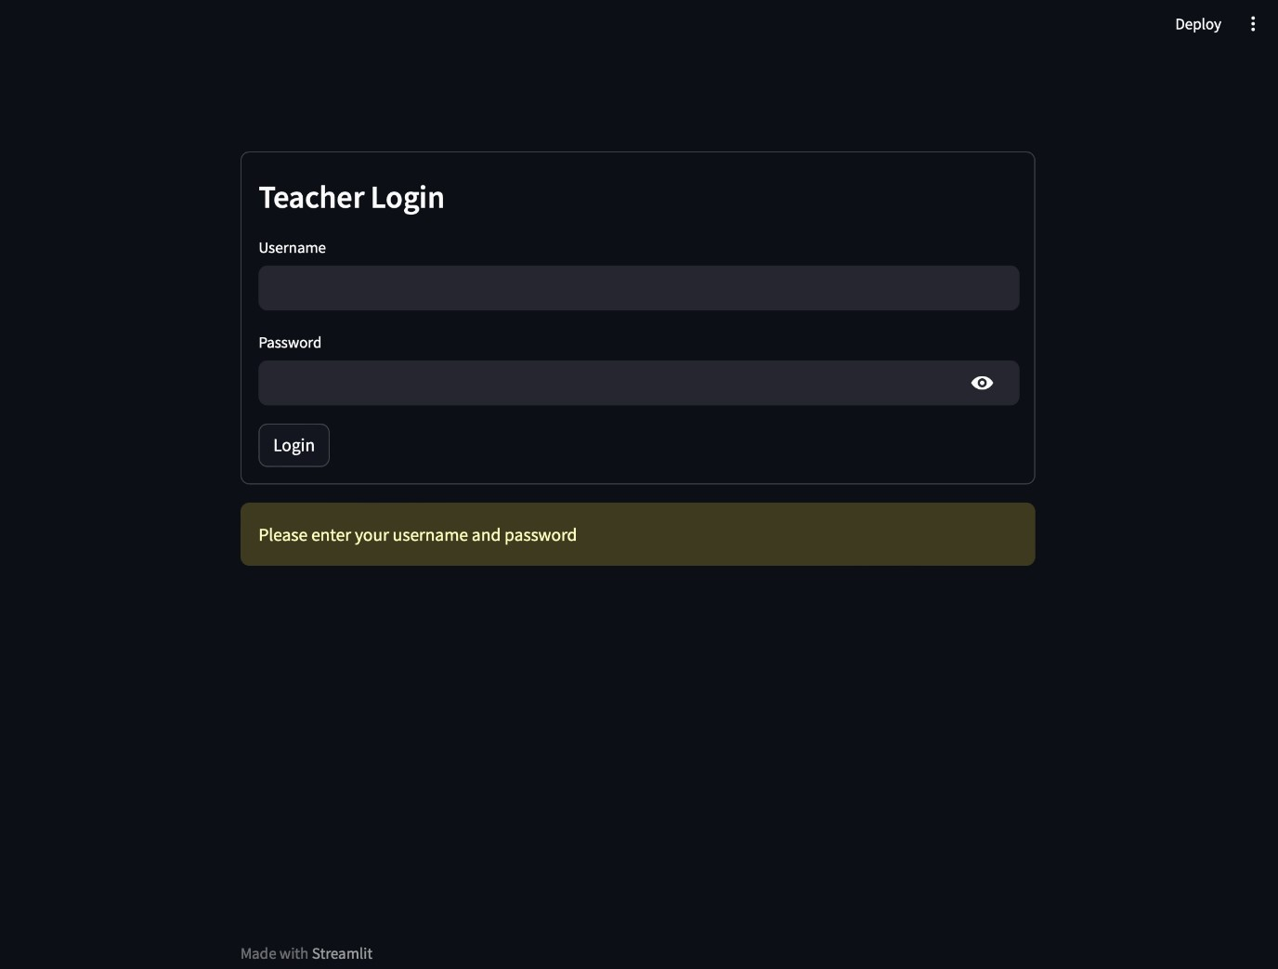

IMPLEMENTATION
The implementation of the attendance system involves several key steps. First, it captures images from the webcam using OpenCV and preprocesses them to optimize facial recognition. Deepface, a Python library, plays a central role by utilizing pre-trained models like Facenet and VGG-Face for accurate facial recognition. The attendance records are managed efficiently using Pandas, enabling structured data storage and analysis.
For user interaction, the system employs Streamlit, providing a web-based, intuitive interface for marking attendance. To enhance security, Streamlit Authenticator ensures that only authorized users can access the system. Real-time feedback is provided to users and administrators to confirm attendance and notify any issues.
The successful integration of these components results in an efficient, accurate, and user-friendly attendance system. It replaces traditional methods with a streamlined, tech-driven solution that is adaptable to various educational and professional settings, showcasing the power of Python and modern technologies in administrative processes.

RESULTS
The facial recognition-based attendance system has demonstrated remarkable results. It excels in both accuracy and efficiency, offering a notable improvement over traditional methods.
Accuracy: The system's use of sophisticated facial recognition models, including Facenet and VGG-Face, has led to minimal false positives and false negatives. This high accuracy ensures that only genuine attendees are recorded, reducing the potential for attendance fraud.
Efficiency: The system significantly streamlines the attendance process. Attendees can swiftly mark their presence, saving time and alleviating administrative burdens, particularly in larger classes or organizations.
User-Friendly Interface: The Streamlit-based frontend has received positive feedback for its intuitive design. Users, whether administrators or attendees, find it easy to navigate and interact with the system, making it accessible to a wide range of users.
Data Management: Pandas efficiently manages attendance records, ensuring they are well-organized and easily accessible. This simplifies the generation of reports and facilitates the tracking of attendance trends.
Security: The integration of Streamlit Authenticator enhances system security, preventing unauthorized access and data tampering. This ensures the confidentiality and integrity of attendance records.
In conclusion, the facial recognition-based attendance system presents a reliable, time-saving, and secure solution for attendance management. Its exceptional accuracy, efficiency, and user-friendliness make it a valuable tool in educational and professional settings, with potential for broader adoption.

CONCLUSION
In conclusion, our project presents a cutting-edge solution to attendance management by harnessing the potential of facial recognition technology. Traditional attendance systems are often tedious and error-prone, but our system offers a robust, efficient, and secure alternative for tracking attendance in various settings.
The integration of OpenCV for image capture, Deepface for facial recognition, Pandas for data management, and Streamlit for the user interface delivers on the project's objectives. OpenCV ensures precise image capture and preprocessing for accurate facial recognition. Deepface's use of advanced models like Facenet and VGG-Face enhances the system's recognition capabilities.
The user-friendly Streamlit interface simplifies the attendance recording process for administrators and attendees alike, with Streamlit Authenticator enhancing security by allowing authorized users access.
Our results underscore the system's efficiency and accuracy in attendance tracking, reducing the time and effort needed for this task. This, in turn, allows educators and employers to focus on core responsibilities.
Moreover, the system's versatility means it can be applied in various contexts and scales, making it a practical solution for both small classrooms and large organizations.
In summary, our project not only modernizes attendance management but also showcases the transformative potential of technology in streamlining administrative processes. The combination of Python, computer vision, machine learning, and user-friendly web interfaces makes our solution an invaluable addition for institutions and workplaces seeking efficient, accurate, and secure attendance tracking.

REFERENCES
- Deepface Library – https://github.com/serengil/deepface
- OpenCV Documentation – https://docs.opencv.org/4.x/
- Pandas Documentation – https://pandas.pydata.org/docs/
- Streamlist Documentation - https://docs.streamlit.io/library/getstarted
- Taigman, Y., Yang, M., Ranzato, M. A., & Wolf, L. (2014).
"DeepFace: Closing the Gap to Human-Level Performance in Face Verification." In Proceedings of the IEEE Conference on Computer Vision and Pattern Recognition (CVPR).
- Schroff, F., Kalenichenko, D., & Philbin, J. (2015). "FaceNet: A Unified Embedding for Face Recognition and Clustering." In Proceedings of the IEEE Conference on Computer Vision and Pattern Recognition (CVPR).
- Parkhi, O. M., Vedaldi, A., & Zisserman, A. (2015). "VGGFace: A Practical Deep Metric for Face Recognition." In International Conference on Computer Vision (ICCV).
- Bradski, G., & Kaehler, A. (2000). "OpenCV." Dr. Dobb's Journal of Software Tools.

